Use Case :
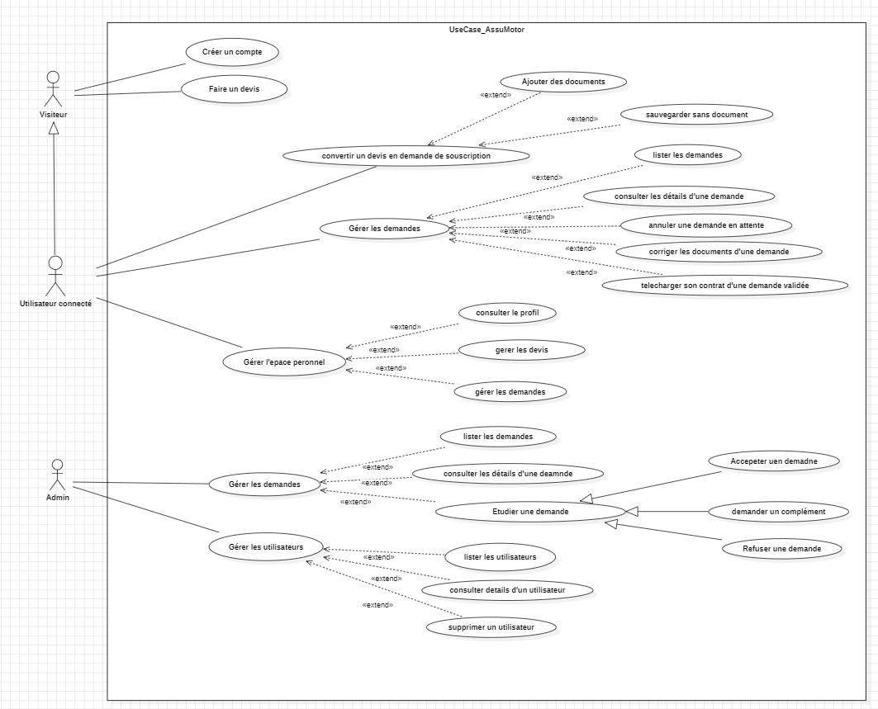

MCD :
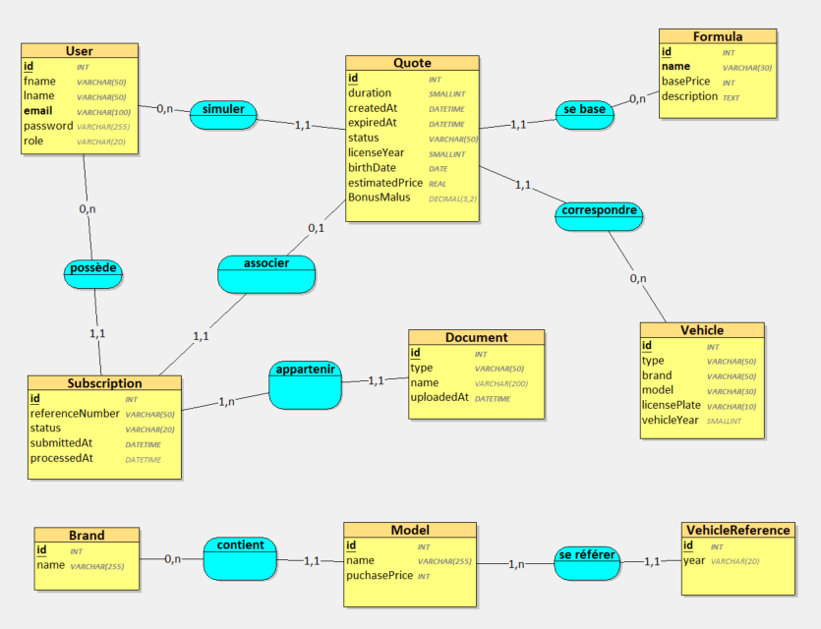

MLD :
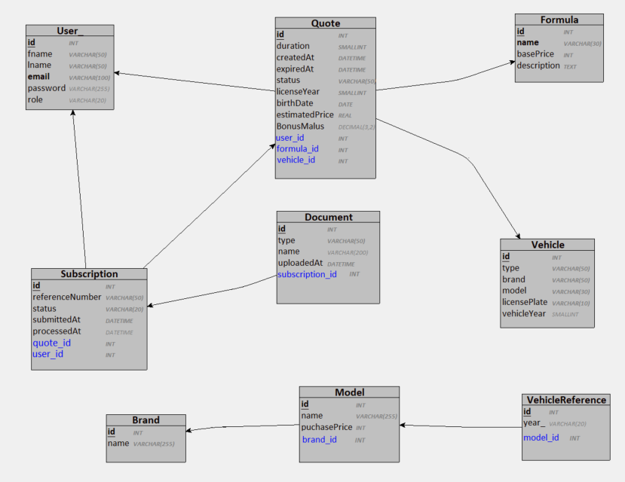

MPD (PhpMyAdmin):
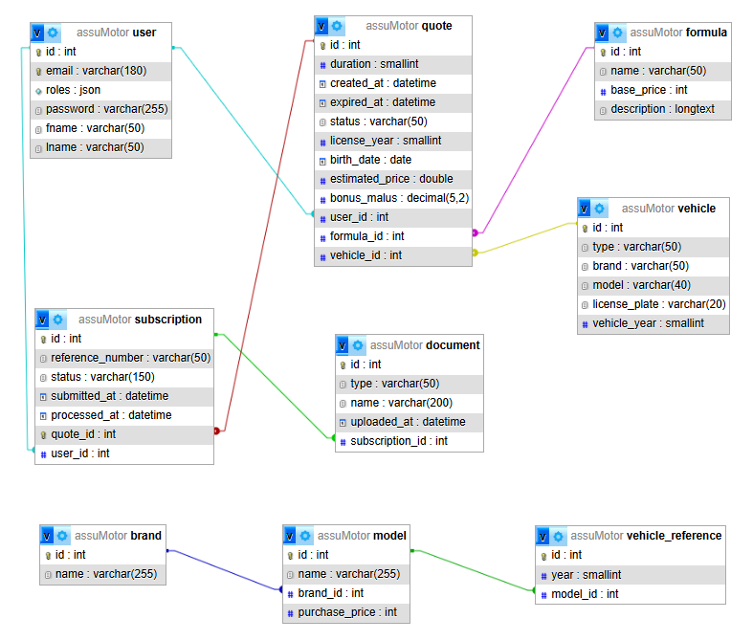
MLD textuel :
User_ = (id INT, fname VARCHAR(50), lname VARCHAR(50), email VARCHAR(100), password VARCHAR(255), role VARCHAR(20));
Vehicle = (id INT, type VARCHAR(50), brand VARCHAR(50), model VARCHAR(30), licensePlate VARCHAR(10), vehicleYear SMALLINT);
Formula = (id INT, name VARCHAR(30), basePrice INT, description TEXT);
Quote = (id INT, duration SMALLINT, createdAt DATETIME, expiredAt DATETIME, status VARCHAR(50), licenseYear SMALLINT, birthDate DATE, estimatedPrice REAL, BonusMalus DECIMAL(3,2), #user_id, #formula_id, #vehicle_id);
Subscription = (id INT, referenceNumber VARCHAR(50), status VARCHAR(20), submittedAt DATETIME, processedAt DATETIME, #quote_id, #user_id);
Document = (id INT, type VARCHAR(50), name VARCHAR(200), uploadedAt DATETIME, #subscription_id);
VehicleReference = (id INT, year_ VARCHAR(20), #model_id);
Model = (id INT, name VARCHAR(255), puchasePrice INT, #brand_id);
Brand = (id INT, name VARCHAR(255));

